WSU Electronic W-2 Announcement
In order to receive an electronic W-2, you must first consent. If you have provided consent in a previous year, you do not need to consent again. Follow the step-by-step instructions to electronically access your W-2 at your convenience.
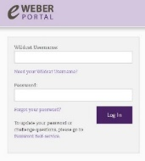

- Login to the eWeber portal
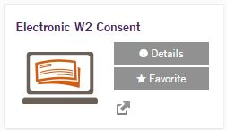
- Select ‘Payroll’ under ‘Categories’
- Select ‘Electronic W2 Consent’
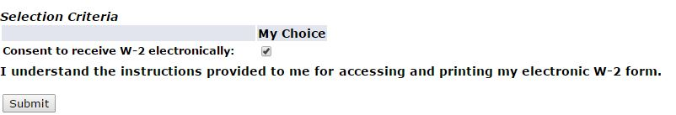
- Select the box to ‘Consent to receive W-2 electronically’

- Faster and more secure delivery than U.S. mail, protecting your sensitive information from loss, theft or delay
- Support Weber State in reducing the University’s costs of printing and mailing individual forms
- Quick and easy access

If you do not take action, your W-2 form will be printed and mailed to your home address during the last week of January. Please confirm that your home address is correct through the eWeber portal.

